Experiment-1

PROVIDE IT AS A SERVICE USING A NY CLOUD SERVICE PROVIDER TO DEMONSTRATE SOFTWARE A S A SERVICE (SAAS).

PROCEDURE:

STEP1: GOTO ZOHO.COM

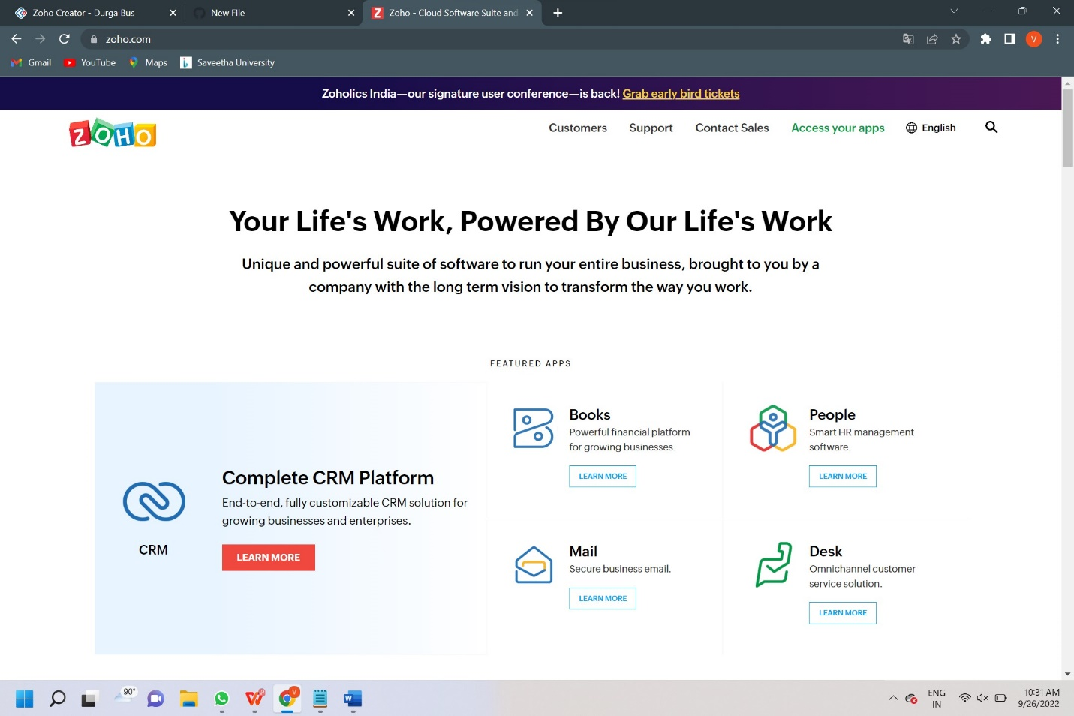

**STEP 2: LOGINTOTHE ZOHO.COM**

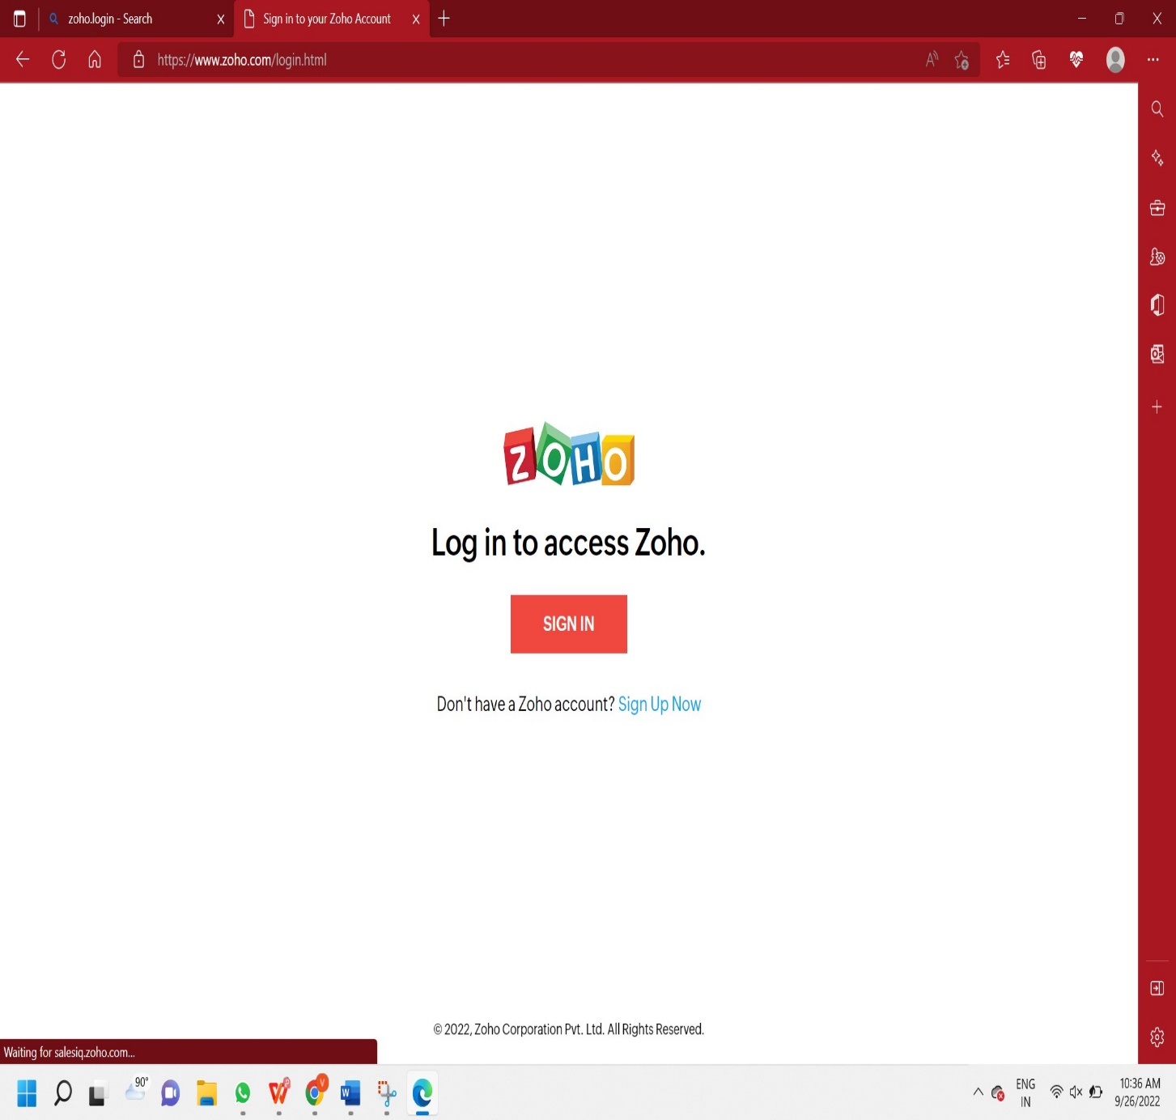

**STEP 3: SELECT ONE APPLICATION**

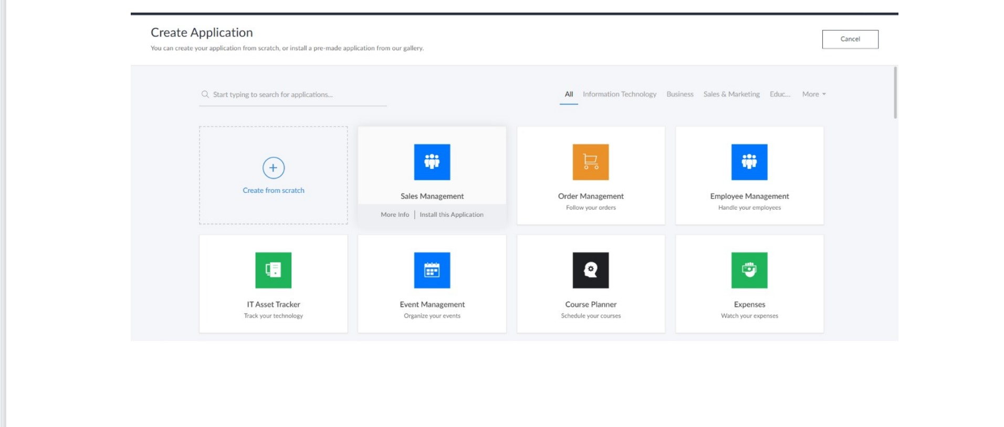

**STEP 4: ENTER APPLICATION NAME**

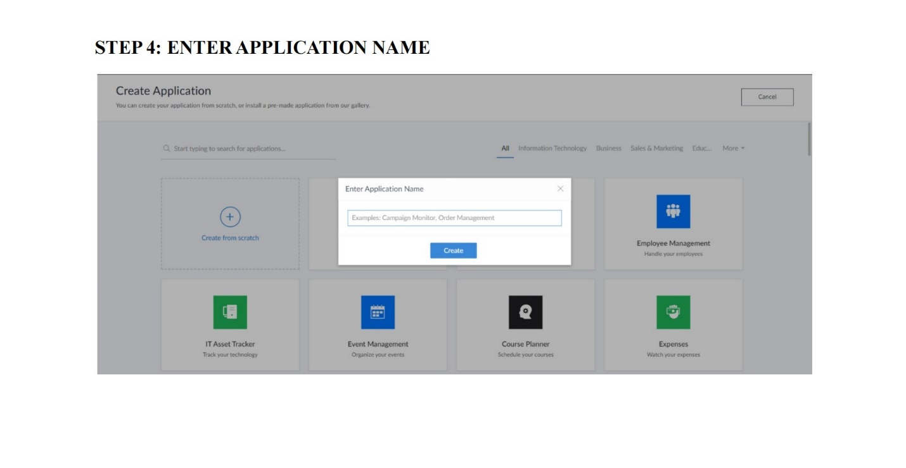

**STEP 5: CREATED NEW APPLICATION**

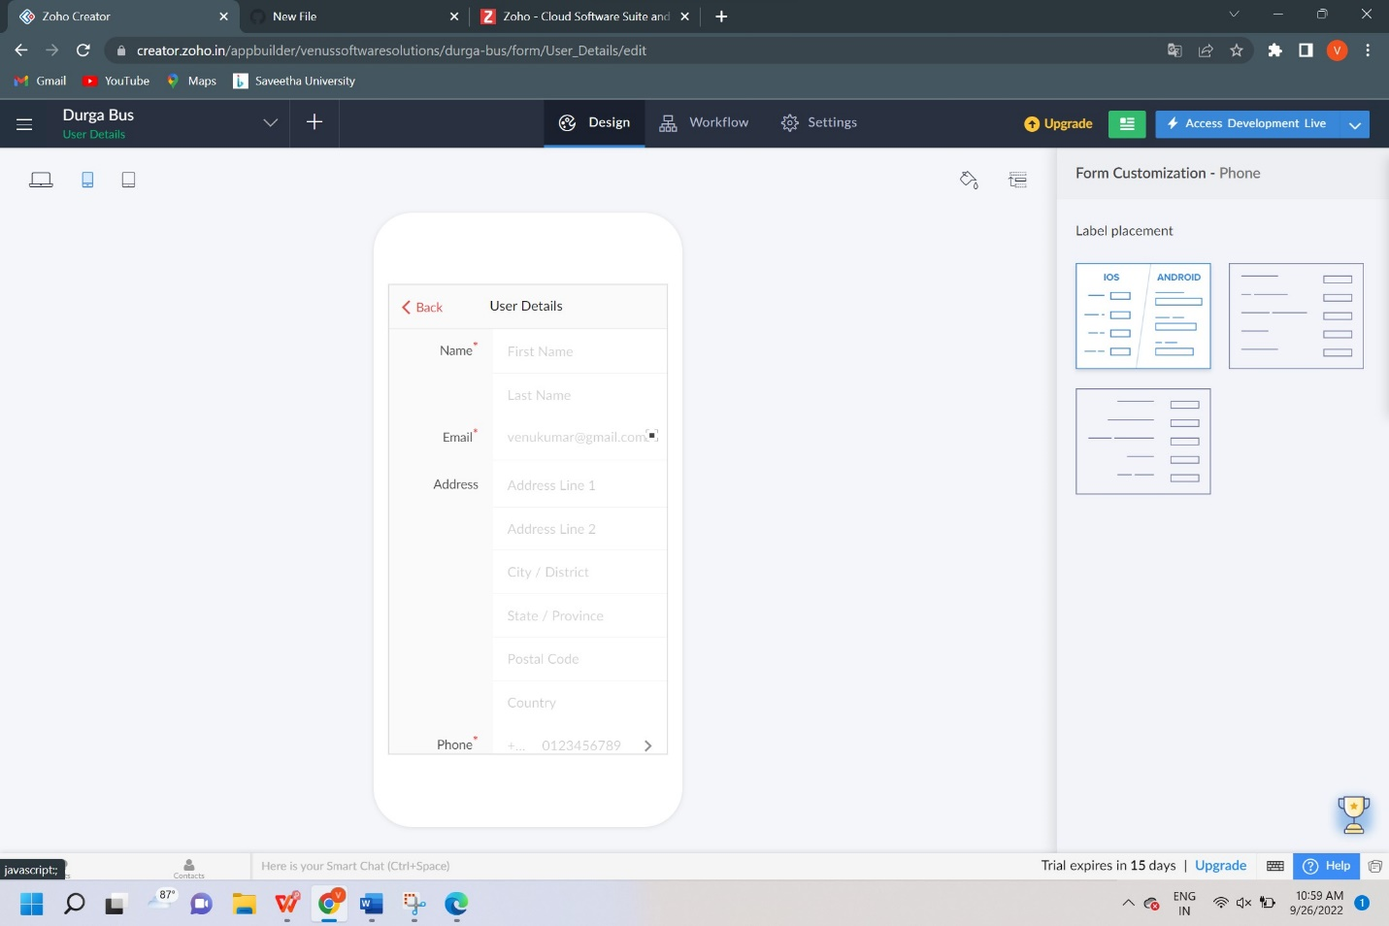

**STEP 6: SELECT ONE FORM**

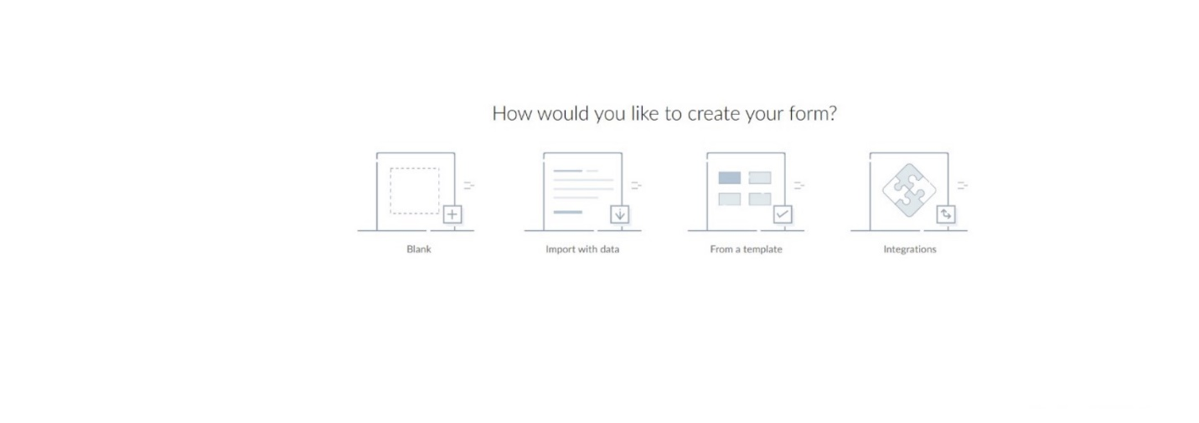

**STEP 7: THE SOFTWARE HASE BEEN CREATED.**

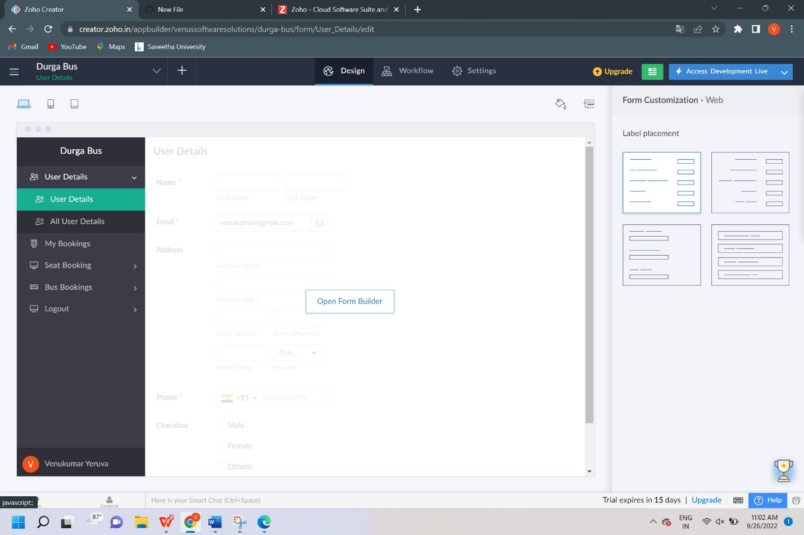

**RESULT:**

